**Attentions Seniors!**

*Do you love Social Studies? Do you want to enhance your college application or resume?*

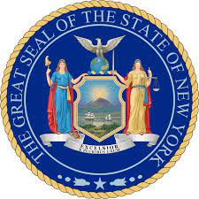

**Earn the**

**NYS Seal of Civic Readiness! (NYSSCR)**

***What is it?***

The Seal of Civic Readiness formally recognizes a high school graduate who has attained a high level of proficiency in their Social Studies coursework and demonstrates civic engagement. It shows you have civic knowledge, skills and actions, mindsets and experiences. There will be a special Seal of Civic Readiness distinction on your high school transcript and diploma.

***Who can earn the Seal of Civic Readiness?***

Seal of Civic Readiness is for all students who demonstrate a high level of proficiency in their Social Studies coursework and have actively participated in a Civic Action Project designed to promote positive change in society.

***What will NYSSCR do for you?***

*Connect you to real-world learning experiences that will promote active civic participation in communities.

*Empower you to make informed decisions about world issues

*Help you to believe in the power of your own voice and actions

*Develop your knowledge, skills and mindset to be a productive civic participant

*Engage you responsibly in our culturally diverse democracy.

*Enhance your scholarship opportunities, college applications and resumes.

***How do I get started earning the Seal of Civil readiness?***

You can get more information by contacting your counselor or Social Studies teacher. They will let you know what you need to do to get started.